JOBSITE POSTER EXAMPLES
USE WITH MDOT FORM 1967
Page 1 of 2
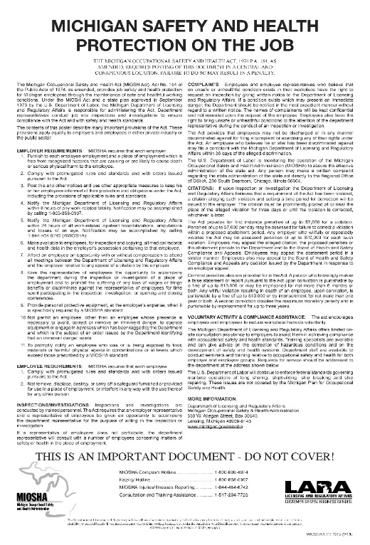  01 – MIOSHA | 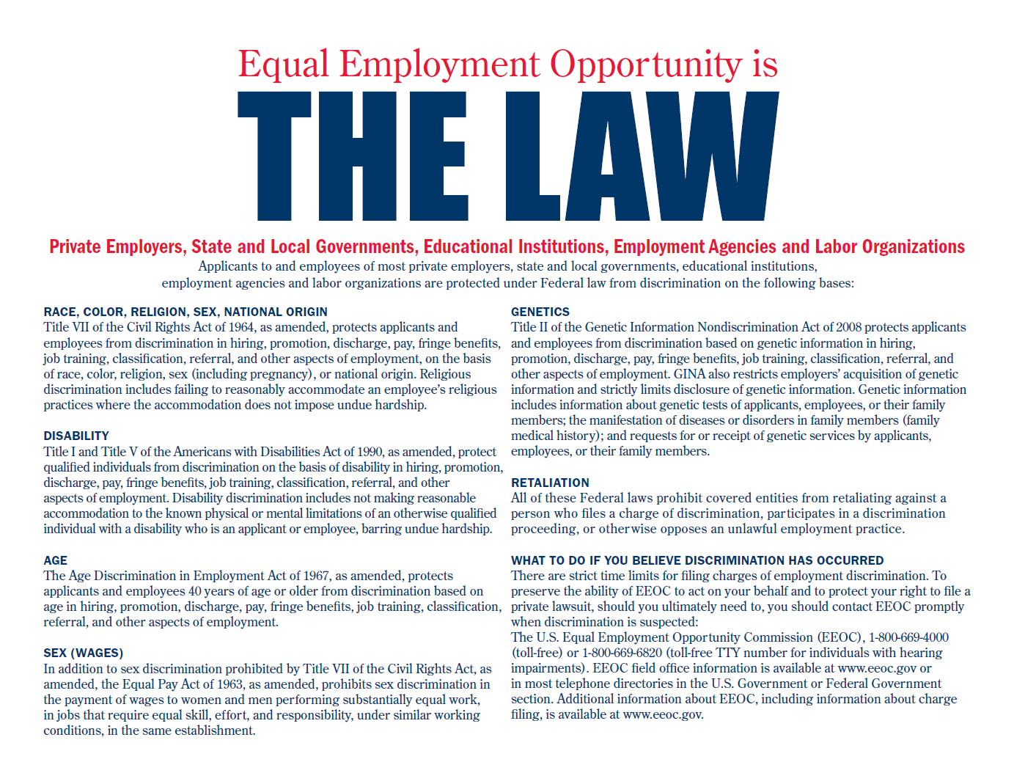  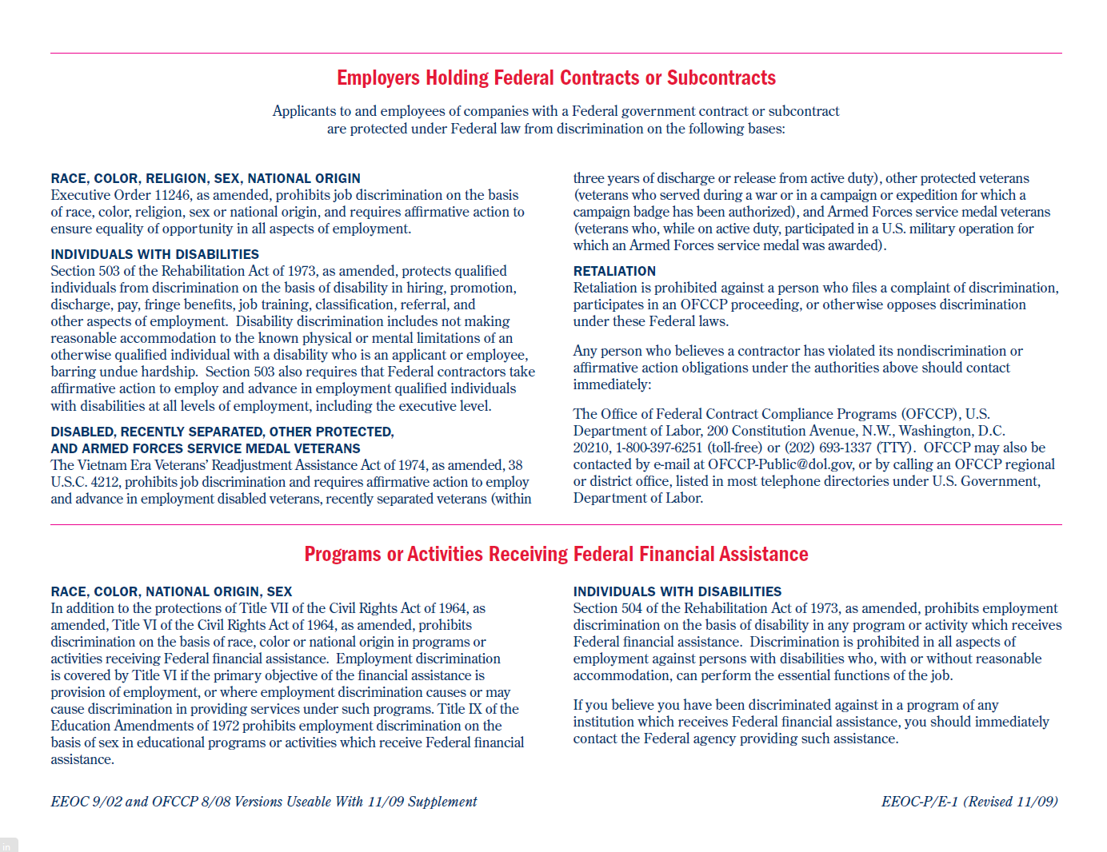  02 – OFCCP 1420 | 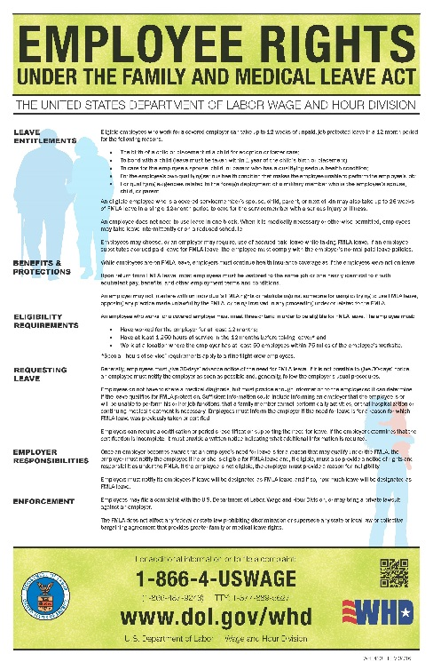  03 – WH 1420 FMLA
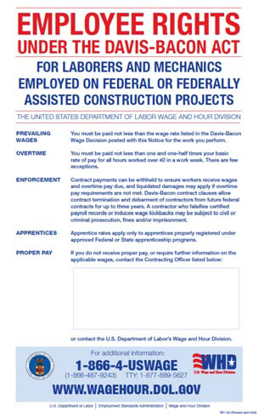  04 – WH 1321 Davis Bacon (English) | 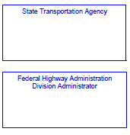    Michigan DOT  425 W. Ottawa St.  Lansing, MI 48933  Russell Jorgenson  315 W. Allegan St.  Lansing, MI 48933  Michigan DOT  Prevailing Wage Compliance Officer  (517) 636-0627 | 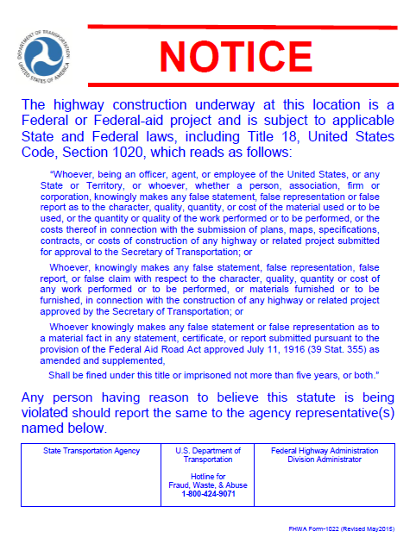  06 – FHWA 1022 Fed Aid Projects
JOBSITE POSTER EXAMPLES
USE WITH MDOT FORM 1967
Page 2 of 2
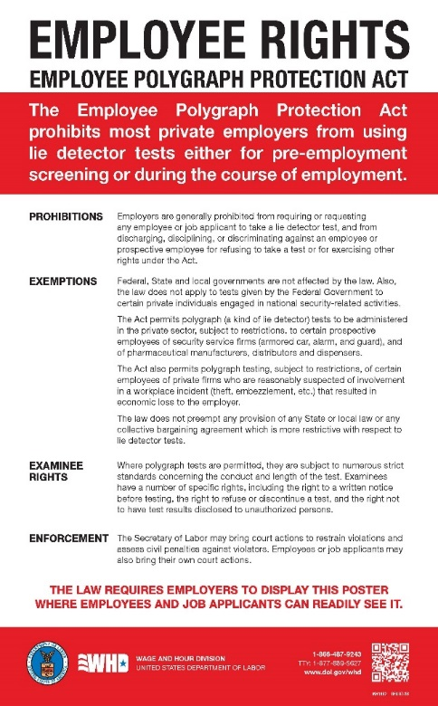  07 - WH 1462  Employee Polygraph Protection Act | 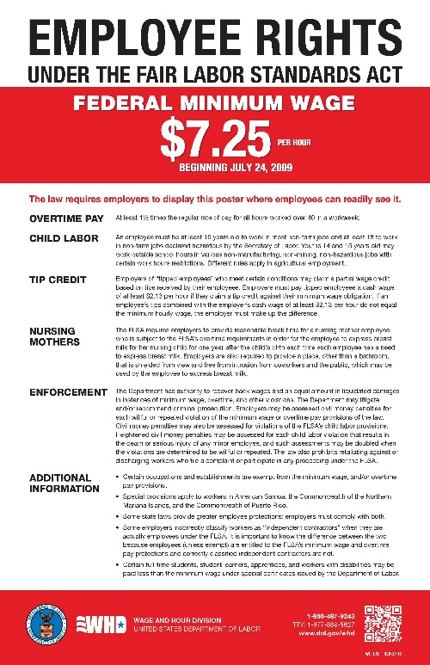  08 – WHD 1088  Federal Min. Wage | 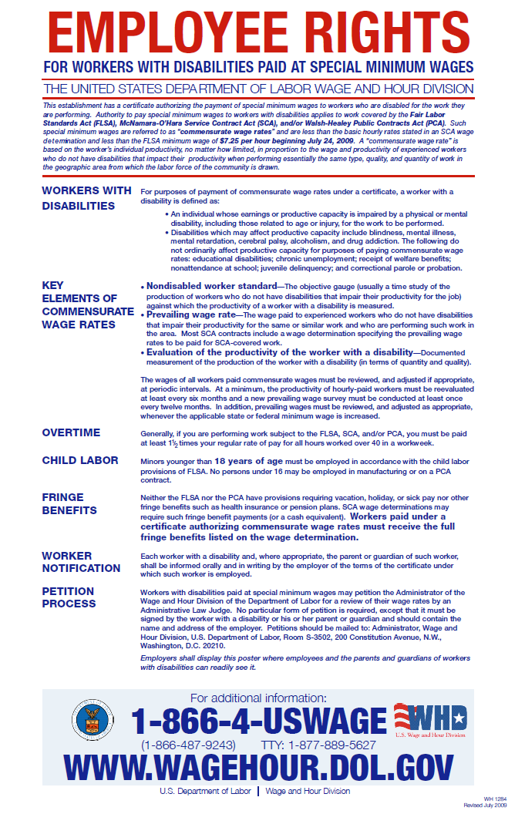  09 – WH 1284  Disab. Paid Min. Wage
  10 – Michigan Civil Rights | 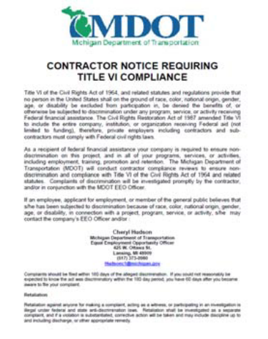  11 – Michigan Title VI Compliance | 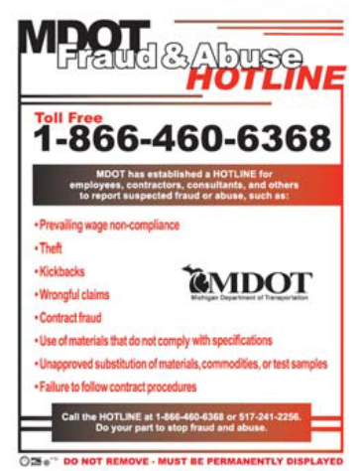  12 – Michigan Fraud and Abuse Hotline
NOTES:
- For a current list of job site posters including revisions please visit the FHWA and USDOL websites.
  - FHWA: http://www.fhwa.dot.gov/programadmin/contracts/poster.cfm
  - U.S. Dept. of Labor: http://www.dol.gov/oasam/boc/osdbu/sbrefa/poster/matrix.htm
- Posters in languages other than English are not required but should be encouraged where applicable.

